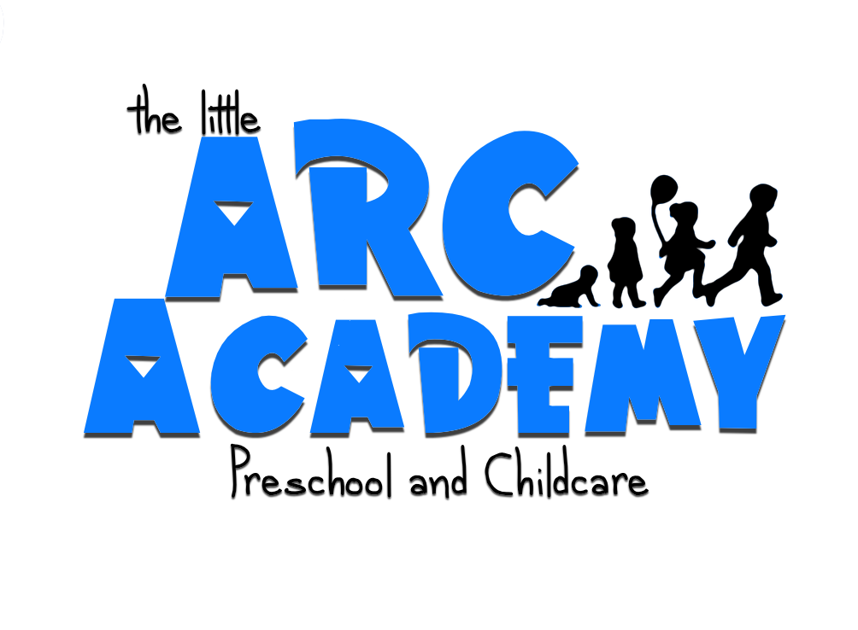

Child’s Name:_____________________________

I hereby acknowledge that I have received and read my copy of The Little ARC
Academy’s 2019 handbook. I understand that these policies and procedures are put into place to help both the center and my child. I will abide by all the policies within this handbook.

________________________________________________
Parent Signature Date

